GOVERNMENT ENGINEERING COLLEGE, BHARUCH

Student's Weekly Report of Internship
Student Name: | PATEL BINIT UMESHKUMAR
Enrollment Number: | 230143107014
Week Duration: | February 12, 2026 - February 18, 2026 (Week 7)
Name Of Organization: | Microsoft Elevate Program (via Edunet Foundation & FICE Education)
External Guide Name: | Adarsh Gupta
External Guide Contact: | 0124-4080107

Work done in last Week with description:

1. Week 7 Module: TensorFlow & Keras Advanced

Description:
Attended comprehensive session on "TensorFlow & Keras" on March 9, 2026. Learned advanced TensorFlow concepts including custom layers, transfer learning, and model optimization techniques.

Key Topics Covered:
- Transfer learning concepts and applications
- Using pre-trained models: VGG16, ResNet50, MobileNet
- Feature extraction vs fine-tuning strategies
- Custom layers and custom training loops
- Data augmentation: ImageDataGenerator, tf.data pipeline
- Model optimization: quantization, pruning
- TensorBoard for visualization and debugging
- Saving and deploying models (SavedModel format)

Hands-on Practice:
Implemented transfer learning using VGG16 pre-trained on ImageNet. Froze base layers and added custom classification head. Trained on custom dataset with data augmentation. Achieved significant accuracy improvement compared to training from scratch. Practiced with TensorBoard for monitoring training metrics.
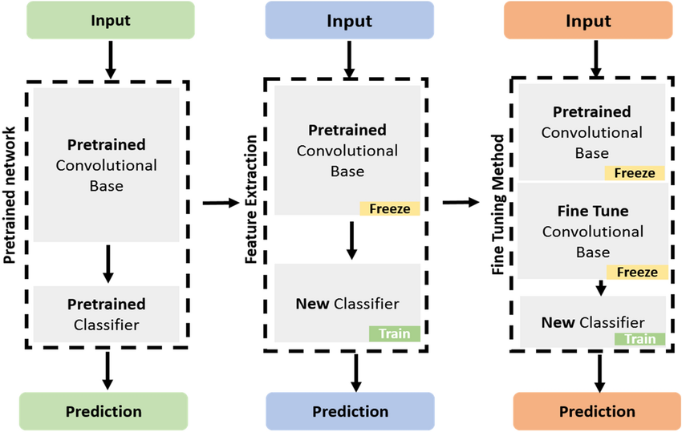

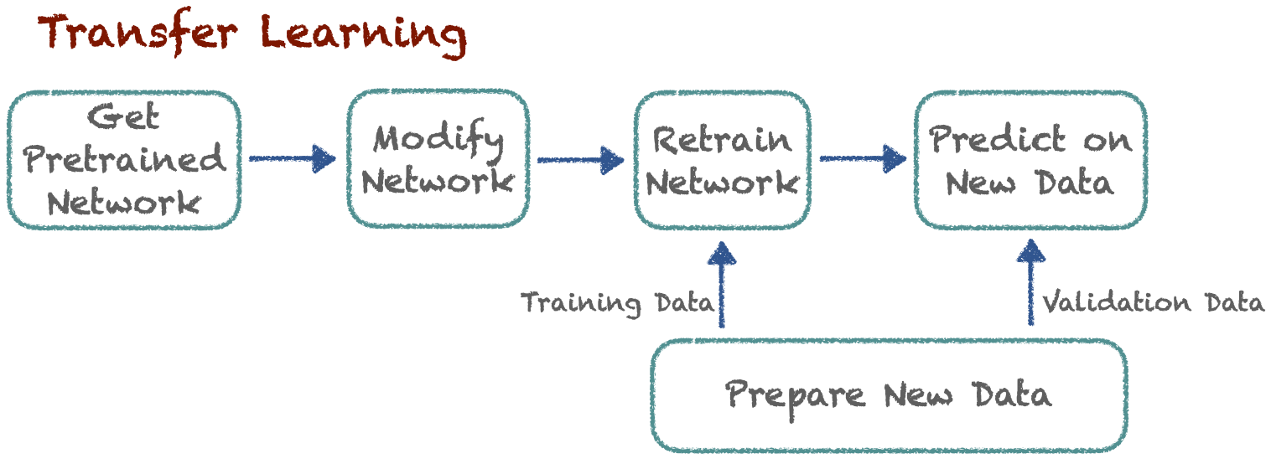
Figure 1: Transfer learning approach showing frozen base layers of a pre-trained model with custom classification layers for new tasks.

2. Week 7 Module: Generative AI Introduction

Description:
Participated in "Generative AI" session on March 11, 2026. Learned about generative models, their applications, and recent developments in GenAI including large language models and diffusion models.

Key Topics Covered:
- Generative vs Discriminative models
- Generative Adversarial Networks (GANs) basics
- Variational Autoencoders (VAEs) overview
- Diffusion models and DALL-E, Stable Diffusion
- Large Language Models: GPT, BERT, Claude
- Prompt engineering fundamentals
- Applications: text generation, image synthesis, code generation
- Ethical considerations in GenAI

Understanding Gained:
Understood the difference between discriminative models (like classifiers) and generative models that can create new content. Learned how GANs use adversarial training between generator and discriminator. Explored practical applications of GenAI in various domains. Recognized that while GenAI is fascinating, the surveillance project focuses on discriminative tasks (object detection).
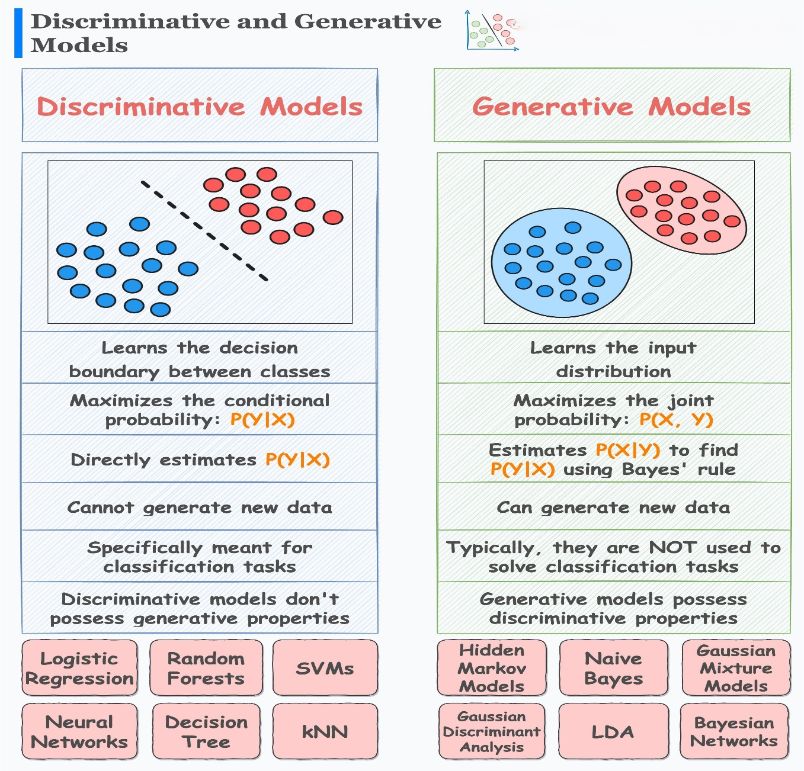
Figure 2: Overview of generative AI models including GANs, VAEs, and diffusion models used for content generation.

3. CNN Deep Dive and Implementation

Description:
Built comprehensive CNN from scratch for image classification. Implemented various CNN architectures and experimented with different configurations to understand impact on performance.

Implementation Details:
- Built CNN for CIFAR-10 dataset (10 classes, 32x32 images)
- Architecture: 3 Conv2D + MaxPool blocks, Flatten, 2 Dense layers
- Used ReLU activation, Dropout for regularization
- Applied data augmentation: rotation, flip, zoom
- Trained for 50 epochs with batch size 32
- Achieved 78% test accuracy
- Visualized learned filters and feature maps

Key Learnings:
Understood how convolutional layers extract hierarchical features from images. Recognized importance of data augmentation for preventing overfitting. Learned to debug CNN performance issues by visualizing activations. This hands-on experience is crucial for understanding YOLOv8 architecture.
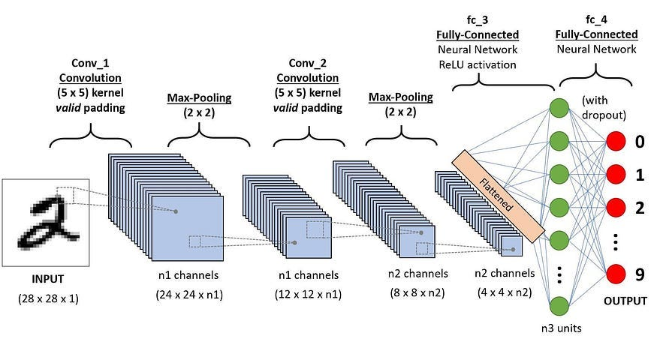
Figure 3: Convolutional Neural Network pipeline demonstrating convolution, pooling, flattening, and dense layers used for image classification.

4. GTU Project - YOLOv8 Installation and Initial Testing

Description:
Installed Ultralytics YOLOv8 library and tested pre-trained model on sample images and surveillance video frames. This marks the beginning of active project implementation phase.

Setup and Testing:
- Installed Ultralytics: pip install ultralytics
- Downloaded pre-trained YOLOv8n (nano) model weights
- Tested on sample images: detected persons, vehicles with confidence scores
- Ran detection on surveillance video frames from UCF-Crime dataset
- Observed detection results: bounding boxes, class labels, confidence
- Tested different model sizes: YOLOv8n, YOLOv8s, YOLOv8m
- Noted inference speed: YOLOv8n ~30 FPS, YOLOv8s ~20 FPS

Observations:
Pre-trained YOLOv8 performs well on common objects (person, car, backpack) but may need fine-tuning for specific surveillance scenarios. Model runs smoothly on GPU. Next step is to prepare custom dataset for fine-tuning on surveillance-specific objects and anomalies.
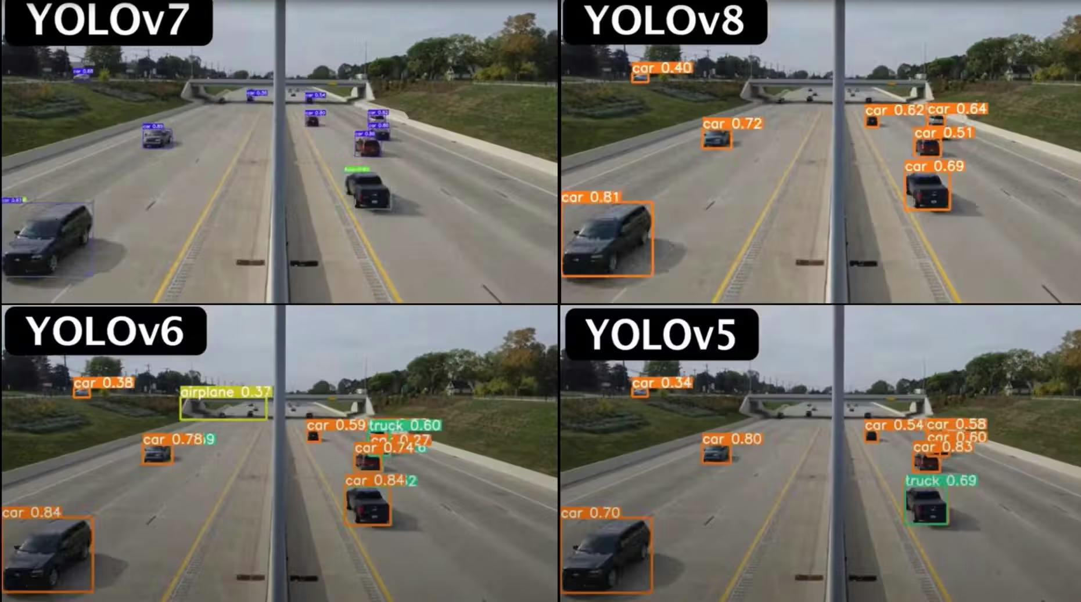
Figure 4: Example output of YOLO object detection showing bounding boxes, class labels, and confidence scores.

5. GTU Project - Dataset Preparation for YOLOv8

Description:
Organized surveillance video frames and prepared dataset structure for YOLOv8 training. Created train/validation splits and documented dataset characteristics.

Work Completed:
- Extracted frames from 15 UCF-Crime videos (1 frame per second)
- Total frames extracted: ~850 frames
- Organized into categories: Normal (500 frames), Anomaly (350 frames)
- Created train/val split: 80% training (680), 20% validation (170)
- Setup folder structure: data/images/train, data/images/val
- Created data.yaml configuration file for YOLOv8
- Documented classes: person, vehicle, suspicious_activity

Next Steps:
Need to annotate frames with bounding boxes using annotation tool (Roboflow or LabelImg) in Week 8. Will then proceed with YOLOv8 fine-tuning on custom surveillance dataset.

6. CNN and TensorFlow Assignment Submission

Description:
Completed Week 7 assignment covering CNN implementation, transfer learning, and TensorFlow advanced concepts.

Assignment Tasks:
- Task 1: Build CNN from scratch for image classification
- Task 2: Implement transfer learning with VGG16
- Task 3: Apply data augmentation techniques
- Task 4: Visualize CNN layers and feature maps
- Task 5: Compare training from scratch vs transfer learning
- Submitted Jupyter notebook with complete code and analysis

Plans for next week (Mar 17-21, 2026):

1. Complete Week 8 Microsoft Elevate Modules
- Attend "Co-pilot" AI coding assistant session (Mar 13)
- Participate in "Cloud Computing Fundamentals" (Mar 16)
- Learn "Azure Introduction" session (Mar 18)
- Practice with GitHub Copilot for coding assistance

2. Annotate Dataset for YOLOv8 Training
- Setup annotation tool (Roboflow or LabelImg)
- Annotate 680 training frames with bounding boxes
- Annotate 170 validation frames
- Export annotations in YOLO format (txt files)
- Verify annotation quality and consistency

3. Begin YOLOv8 Fine-tuning
- Configure YOLOv8 training parameters
- Start fine-tuning on custom surveillance dataset
- Monitor training metrics (loss, mAP, precision, recall)
- Test model on validation set

4. Azure Cloud Setup for Project
- Create Azure Storage Account
- Setup Blob Storage containers for videos and frames
- Test uploading and downloading files from Azure
- Learn Azure SDK for Python

5. Project Documentation Update
- Update GitHub repository with YOLOv8 code
- Document dataset preparation process
- Add training results and metrics
- Create project progress report

Total Working Hours: 38 hours
Signature of Student: _____________________
The above entries are correct, and the grading of work done by Trainee is:
Excellent | Very Good | Good | Fair | Below Average | Poor
☐ | ☐ | ☐ | ☐ | ☐ | ☐

Signature of External Guide with Company Seal: _____________________
Date: ___________
Signature of Internal Guide: _____________________
Date: ___________

